**PAPER TITLE**

**(ALL CAPS, TIMES NEW ROMAN, 14 PT, BOLD, CENTЕRED)**

**PAPER TITLE IN ENGLISH (if the paper is written in Bulgarian)**

**Academic title, degree, name and surname(s) of the author, place of work (Times New Roman, 12 pt, centered)**

**Abstract:** (no longer than 300 words or 1,900 characters)

(font Times New Roman, 11 pt, Justify)

**Keywords:** (three to five)

(Times New Roman, 11 pt, Justify)

**Introduction**

The paper shall be formatted as follows: page size 21 cm × 29,7 cm (А4), Top: 2 cm, Bottom: 2 cm, Left: 2 cm, Right: 2 cm; Font Times New Roman, 12 pt, Justify, Spacing – 1 (Single) and first line indent 1.15 cm (First line).

**Pages shall not be numbered**.

Papers are to be sent to: [lingua.tsenov@gmail.com](mailto:lingua.tsenov@gmail.com)

**In-text citations shall be of the type (Ivanov, 2021:55),** i.e., the author’s last name, year of publication for the cited source should appear in parenthesis, and the page number should be inserted after the colon. When referencing, please indicate only the year of issue. One complete reference for each source shall appear in the reference list at the end of the paper.

Explanatory notes (footnotes) should be positioned on the same page.

Special emphasis should be in *Italic*.

**Figures and tables**

Figures and tables shall be positioned at the corresponding place in the text, numbered and entitled in Bold. They shall be separated by the main text by one line. Figure captions are placed below them and centered.

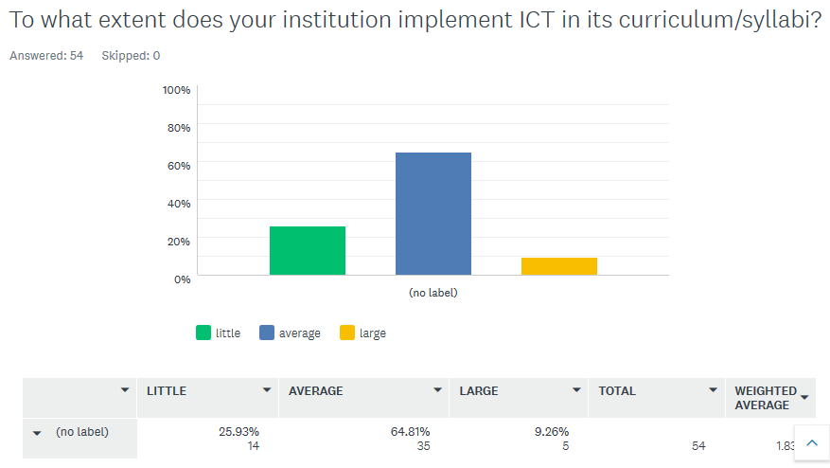

**Fig. 1**. Title.

Table titles are positioned above. The text in the tables is to be formatted 10 pt, Times New Roman. The title of each column is to begin with a capital letter (See example).

**Table 1.** Title

| Main group |  | Types | | | Result |
| --- | --- | --- | --- | --- | --- |
|  |  |  |  |
|  |  |  |  |  |  |
|  |  |  |  |  |
|  |  |  |  |  |  |

**REFERENCES**

Font: Times New Roman, Size:10, Alignment: Justified; The reference list should be the last page of your paper and alphabetized – references first in Cyrillic and second in Latin script. APA Format Citation standard should be used **APA Format Citation Guide** (<https://owl.purdue.edu/owl/research_and_citation/apa_style/apa_formatting_and_style_guide/general_format.html>)